EXERCISE 1
SIXOLISE KLAAS
DATA ANALYTICS (AUG)
07 AUG 2026

Question 1: Retrieve all columns from the employees table. 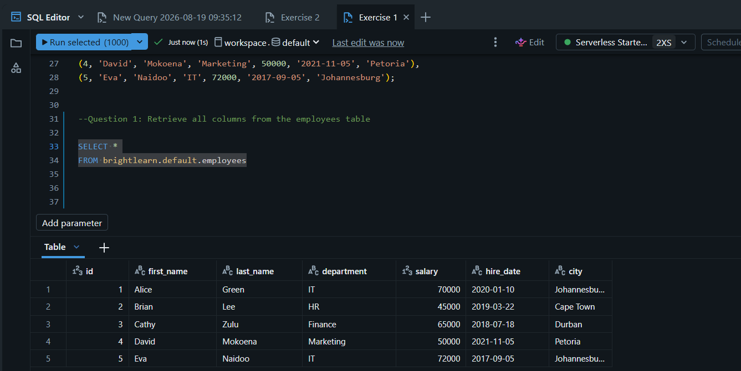

Question 2: Find all unique departments.
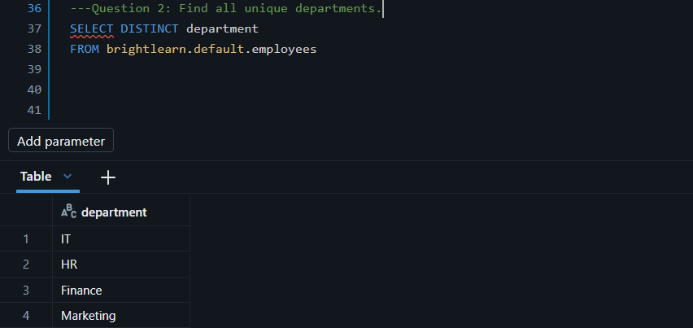

Question 3: Retrieve first and last names ordered by salary descending.
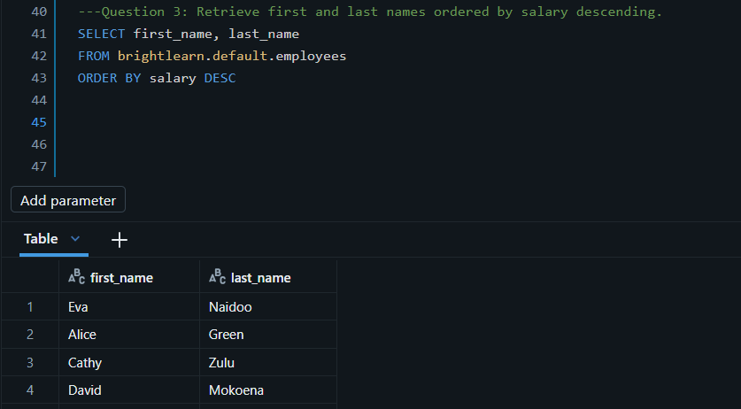

Question 4: Retrieve the top 3 highest-paid employees.
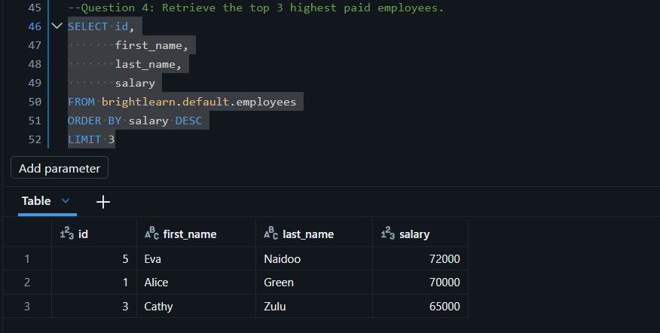

Question 5: Find employees in the IT department.
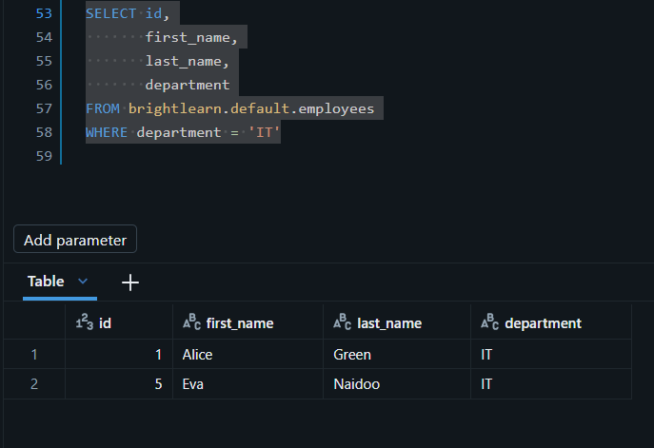

Question 6: Find employees in Finance with salary > 60000
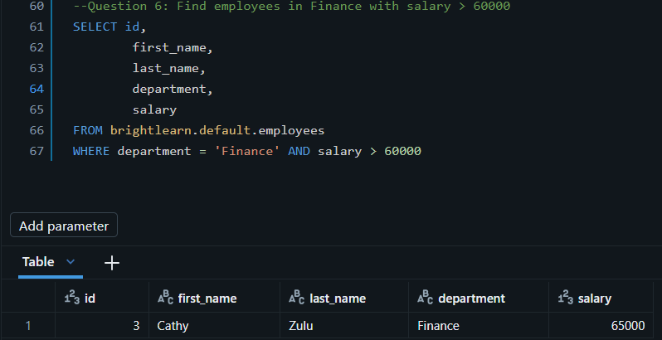

Question 7: Find employees in HR or Marketing.
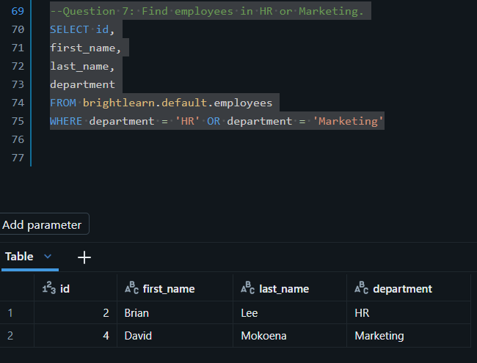

Question 8: Find employees not in IT.
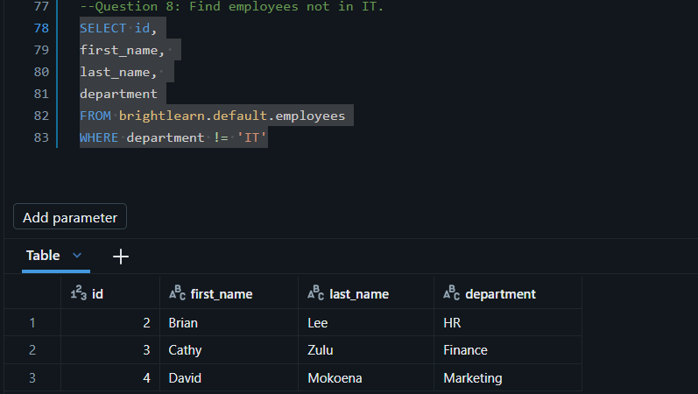

Question 9: Find employees in IT, HR, or Finance using IN.

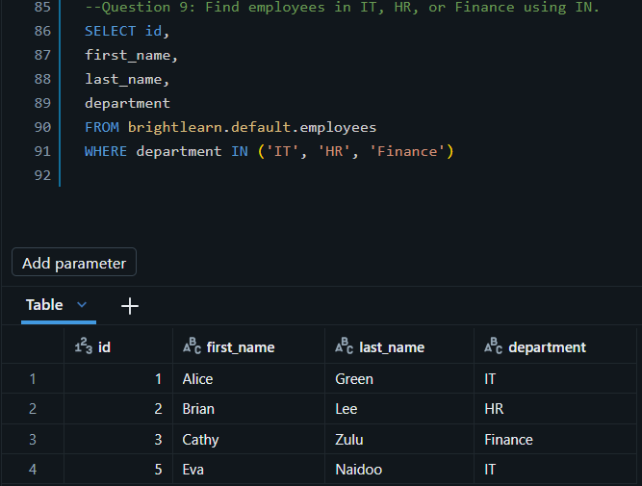

Question 10: Find employees in IT with salary > 65000 and city Johannesburg.
